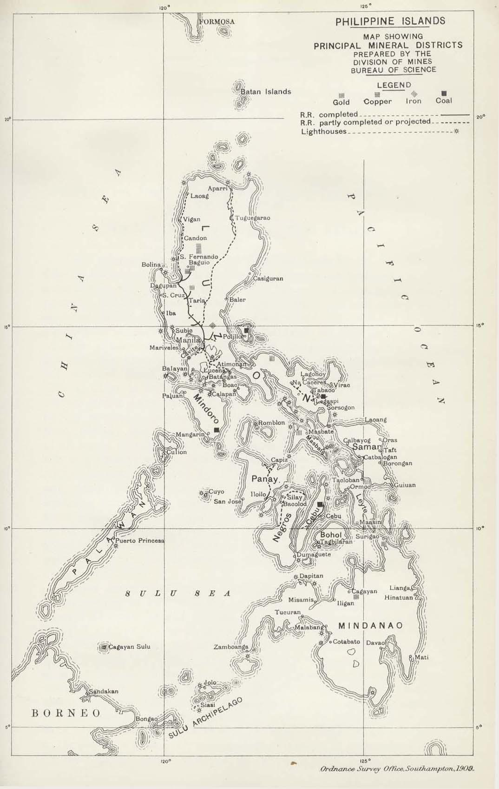

Magellan is known for aiding in the early Spanish discovery of the Philippines; however, this is a big misconception as he . In 1521, Magellan began his journey through the Philippine islands. He began in Jomon Jol, which is on Samar, a place that he described as having very lofty mountains. Because he was on the search for food, his guides sent him to Cebu. He encountered over two-thousand warriors who wanted nothing more than to get rid of the Spaniards. Fortunately, with the help of their leader Hamalbar, they were able to create a compact between the people. Afterward, he traveled to Dapitan and Cagayan Sulu. On their route, the Spaniards celebrated their landing with a service of mass which the Filipinos witnessed and wanted to embrace. The Spaniards baptized over eight-hundred Filipinos admitting them into their religion. His next two stops were the Palawan island and then to Borneo. Sadly, he was pierced by an arrow through the leg and spear-thrust through the breast in combat, thus ending his journey.

