Systems of Writing among the Filipinos.—When the Spaniards arrived in the Philippines, the Filipinos were using systems of writing borrowed from Hindu or Javanese sources. This matter is so interesting that one can not do better than to quote in full Padre Chirino’s account, as he is the first of the Spanish writers to mention it and as his notice is quite complete.
“So given are these islanders to reading and writing that there is hardly a man, and much less a woman, that does not read and write in letters peculiar to the island of Manila, very different from those of China, Japan, and of India, as will be seen from the following alphabet.
“The vowels are three, but they serve for five, and are,
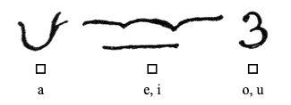
The consonants are no more than twelve, and they serve to write both consonant and vowel, in this form. The letter alone, without any point either above or below, sounds with a.

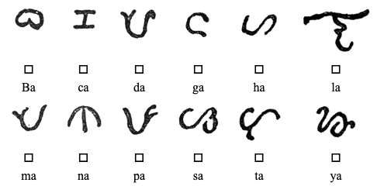

Placing the point above, each one sounds with e or with i.
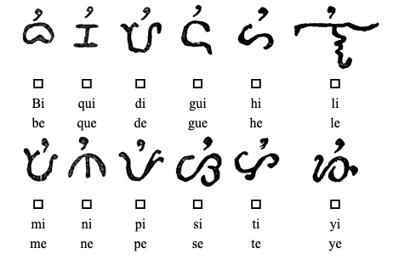

Placing the point below, it sounds with o or with u.
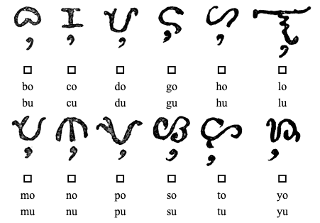

On the back in BLACKLIGHTS! (write on this paper or another paper!)
LOO_
U_DE_
_HE
BOO_

