SCHEDULE OF ROTATION AND GROUP MEMBERS

History: Arias & Mateo -Backup Matthew- SILVER
Alyssa D.
Evie L.
Deven K.
Jaden M.
Livi P.
Mr. Falls
Mr. Denvir

Culture: Caroline & Mrs.Trevino GREEN
Naim L.
Joslyn H.
Quinton X.
Raymond G.
Trinity G.
Mr. Palalay
Mr. Obispo

Friends: Kristwen & Francis RED
Donyale W.
Frederick V.
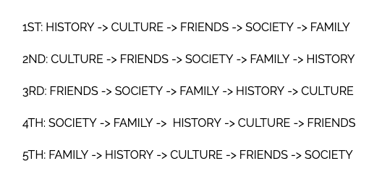
Kevin M.
Shirell W.
Mrs. Windish
Mrs. Dajero?
Jem B.

Society: Kori & Maiyah YELLOW
Ceska T.
Habiba A.
Jay S.
Olivia C.
Mrs. Bergano
Mr. Bergano
Alyssa N.

Family: Jastine & Lequan BLUE
Dominick C.
Joseph M.
Josephine S.
Kelly B.
Zale S.
Arnel C.
Mrs. Nina Magpili-Smith
Mr. Smith

